

**CSE 227**

**Project Proposal**

[FARMING CONSULTANCY SERVICES]

**By**

AVICK SINHA-202005812

MUHAIMIN BIN HABIB-202005412

MD OMAR FARUK-202001512

SYEDA SIRAJUM MUNIRA-202001112

Date: [27.10.2022]

1. **Abstract**

The project which my team and I will make, is an agriculturally based website that will help the farmers of our country to get relevant items or advice for agricultural purposes. Farmers will also be able to buy and sell agricultural items via the website.

1. **Background and introduction of sponsor/client and problem statement(s)**

The name of the project that my team and I will make is the “Farming Consultancy Services” website. This website will fulfill the needs and demands of the farmers of our country moreover it will have information and advice regarding farming methods, items, etc. Farmers are the main client of our website. They face several hurdles in our country to get the relevant things and guidance for agricultural purposes for example they need particular seeds, pesticides, or yeast to yield their crops but they don’t get it on the open market on time. Farmers also don’t get relevant advice or information regarding the latest methods to farm crops. They still use outdated techniques to yield crops. Our website will help the farmers of our country to solve all these problems

1. **Literature Review**

Our group has studied several research papers around the problem statement related to our project. According to one research paper, the agricultural problem in Bangladesh has a lot of challenges such as finding proper land that is fertile for better crop yield, Climate changes, improper usage of fertilizers, not watering the crops properly, pests and diseases, etc. [1]. Our proposed solution of consultancy will aim to solve this kind of problem. Another research paper was done on how websites help the aquaculture industry, stating that it has a huge market on the web and is actively used by most users for buying/selling fish [2]. So, we think that the e-commerce feature on our website will be able to acquire a sizeable market in the agricultural farming field as it’s still in the early phase in Bangladesh. Additionally, our website could have the potential to solve the food scarcity problem that Bangladesh is going to face soon. The problem is not only for our country rather it’s a global problem. Research on sustainability factors of rice farming in Bangladesh states that the lack of education about farming and inexperienced advice is leading to a bad yield of crops. It also states that not adopting proper eco-friendly practices is also a serious issue in farming in Bangladesh [3]. This clearly aligns and gives significance to our problem statement and the solution we proposed below. We did some research to see if any websites have tried to solve the problems. Though we found some websites that shared a similar interest as our project which were titled “Agricultural Consulting Services” [4] and “Saline agriculture Worldwide” [5] but none were not user friendly, maintained, or created by someone in Bangladesh.

1. **Project Rationale**

Our team has been motivated to work on this project because of many reasons. First of all, the farmers of our country are suffering due to low crop yield and because of this scarcity of food is increasing. The farmers in the rural areas of our country are using medieval & ancient farming techniques which is the sole reason for low crop yield. Due to low crop yield, farmers have financial problems. Poverty among them is increasing drastically and some of them are close to death due to hunger. Our country has to import a big percentage of food from abroad due to these problems and it is affecting the economy of our country. We want to do this project to eliminate these problems because if the agricultural problem of our country is solved then a lot more problems will be solved automatically. We hope to learn the needs and demands of farmers in our country from our research.

1. **Aims and Objectives**

The main goal of this project is to help the farmers of our country to buy and sell agricultural products through a website. The website will also contain new techniques and methods to farm crops. For example, it can show which tractor is best for farming and what is the cost of it. The items which will be ordered by the farmers through the website will be delivered to them as soon as possible. Farmers will be able to create an account on the website.

1. **Scope of the Project**

The scope of the project is very wide and has very big potential to solve most of the problems of the farmer which we have to implement over a long course of time. Our primary target is to create a fully functional dynamic website aiming to solve the above-mentioned problems relating to farming.

Our primary goal or features for the project is listed below.

* To create a website that is user-friendly for farmers and includes language support for their native language which our case is Bengali.
* To create a marketplace for selling crops produced by the farmers, which is accessible by verified farmers and vendors who can sell their agricultural-related products but our primary focus is to ensure that the farmers get their expected price via this feature.
* Our next and most challenging goal is to create a user interface where farmers can consult expert agriculturists about anything related to farming. It could be open-source first where volunteer agriculturists can help the farmers. In the future, we can hire expert verified agriculturists to help the farmers depending on the business model we adopt.
* Lastly, to create a technology section that features the latest technology, fertilizers, and farming tools so that they can easily be educated about them with the potential to sell them on our website.
* User/Admin Dashboard so that the consultant and the user can keep track of the status of the problem they asked about.

We hope to deliver all of our primary goals within the deadline of the project. As it’s a volunteer-based project using open-source technology at the moment, the cost of the project is expected to be very minimum or close to none

1. **Proposed Methodology**

We aim to create a website using the MERN stack which comprises MongoDB as our Database, Express.JS, and Node.JS as the backend, and using React.JS with HTML and Tailwind CSS to create the frontend for the website. A flow chart of how they will interact is given below.

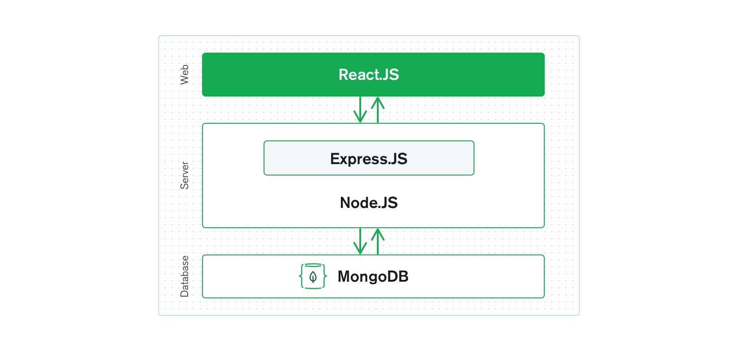

1. **Proposed solution and anticipated results**

Using the above-mentioned Methodology to create the website along with our primary goals of adding the features we mentioned, we are trying to solve the most crucial and foremost problem that a farmer experiences during its lifecycle of farming. If we can successfully execute our planning it will solve the most problems that a farmer faces during their farming lifecycle. The anticipated results could be listed as follows:

* Farmers have free, affordable service at the palm of their hands without going to professionals who charge a large amount of money.
* A consultation system where farmers can consult about any type of crop from anywhere with anyone around the world which could include the best agriculturist who can give free advice to them without ever spending a single penny.
* A marketplace only dedicated to the farmers could build an entire ecosystem where the consumers/vendors could directly buy the fresh produce from the farmers. This will ensure every client such as farmers, consumer, and vendors all will get their desired price.
* A user-friendly website with farmer being our primary user base so that they can use the website with minimum knowledge of technology.

1. **Schedule of activities and Gantt chart**

|  |  |
| --- | --- |
| **Activity** | **Tentative Date** |
| **Project Proposal and Presentation.** | 01/11/2022 |
| **Backend System with Login Features** | 08/11/2022 |
| **Landing Page with Services Pages** | 27/11/2022 |
| **User/Admin Dashboard** | 3/12/2022 |
| **Testing and Deployment** | 12/12/2022 |

1. **References**

[1] M. H. Mondal, “Crop Agriculture of Bangladesh: Challenges and Opportunities,” *Bangladesh J. Agric. Res.*, vol. 35, no. 2, pp. 235–245, Jan. 2010, doi: 10.3329/BJAR.V35I2.5886.

[2] Z. S. Andreopoulou, A. K. Kokkinakis, and T. Koutroumanidis, “Assessment and optimization of e-commerce websites of fish culture sector,” *Oper. Res.*, vol. 9, no. 3, pp. 293–309, Mar. 2009, doi: 10.1007/s12351-009-0036-8.

[3] S. Shahid and H. Behrawan, “Drought risk assessment in the western part of Bangladesh,” *Nat. Hazards*, vol. 46, no. 3, pp. 391–413, Sep. 2008, doi: 10.1007/S11069-007-9191-5.

[4] “Agricultural Consulting Services.” https://acscrops.com/ (accessed Oct. 29, 2022).

[5] “Saline Agriculture, a practical solution to a global problem.” https://www.salineagricultureworldwide.com/ (accessed Oct. 29, 2022).